Visualization of Structure-Property Relationships:
Spanning the Length Scales (nano to macro)
http://www.jwave.vt.edu/~rkriz/Pubs/NSF_SEVC/NSF_sevc.doc

Submitted to the NSF Science and Engineering Visualization Challenge
http://www.nsf.gov/od/lpa/events/sevc/

March 3, 2003

by

R. D. Kriz*, A. A. Ray, J. T. Kelso, D. Farkas**, and R. E. Flanery Jr.***
***Oak Ridge National Laboratories, Oak Ridge, Tennessee, and
**Department of Materials Science and Engineering,
*Department of Engineering Science and Mechanics, and
Department of Computer Science
Virginia Tech
Blacksburg, Virginia

Description (100 words)

Recent development of networked collaborative immersive software [1-3] allows more accurate visual analysis of complex connected wave-velocity surfaces propagating through anisotropic crystals. Existing topologies, used for sub-classification within orthorhombic symmetry [4-6], were studied using these immersive tools. From Christoffel’s equation the fourth order elastic stiffness tensor, Cijkl, uniquely defines these topologies where the collection of all wave speeds, v, (topology) and their vibration directions, αk, correspond to the wave propagation direction, νk, and color is defined by αkνk [7]. Together both topology and color uniquely represent Cijkl for Ca[HCOO]2. Insight occurs when the observer is “immersed” inside the crystal (nano-structure) and the wave velocity (macro-property) topology. Polar covalent bond orientations are seen to align along stiffer directions where faster longitudinal wave speeds appear as purple bulges.

REFERENCES

1. DIVERSE (2001): http://diverse.sourceforge.net
2. DIVERSE Atomview (2002): http://www.sv.vt.edu/future/cave/software/D_atomview/
3. DIVERSE Collab Tools (2003): http://www.sv.vt.edu/future/cave/software/D_collabtools/
4. Musgrave, M.J.P., "On an Elastodynamic Classification of Orthorhombic Media," Proc. R. Soc. Lond.
A374, p. 401, 1981.
5. Ledbetter, H.M. and Kriz. R.D., "Elastic-Wave Surfaces in Solids", Physica Status Solidi, Vol.114,
pp. 475-480, 1982.
6. Kriz, R.D., and Ledbetter, H.M., "Elastic Wave Surfaces in Anisotropic Media", Rheology of
Anisotropic Materials, C. Huet, D. Bourgoin, and S. Richemond, Eds., CEPADUES-Editions,
Toulouse, France, pp. 79-91, 1986.
7. Kriz, R.D., Farkas, D., and Batra, R.C., “NSF-Combined Research and Curriculum Development:
Computer Simulation of Material Behavior -From Atomistic to The Continuum Level”,
Course module: Introduction to Mechanical Behavior of Anisotropic Materials (2002):
http://www.jwave.vt.edu/crcd/kriz/lectures/Anisotropy.html

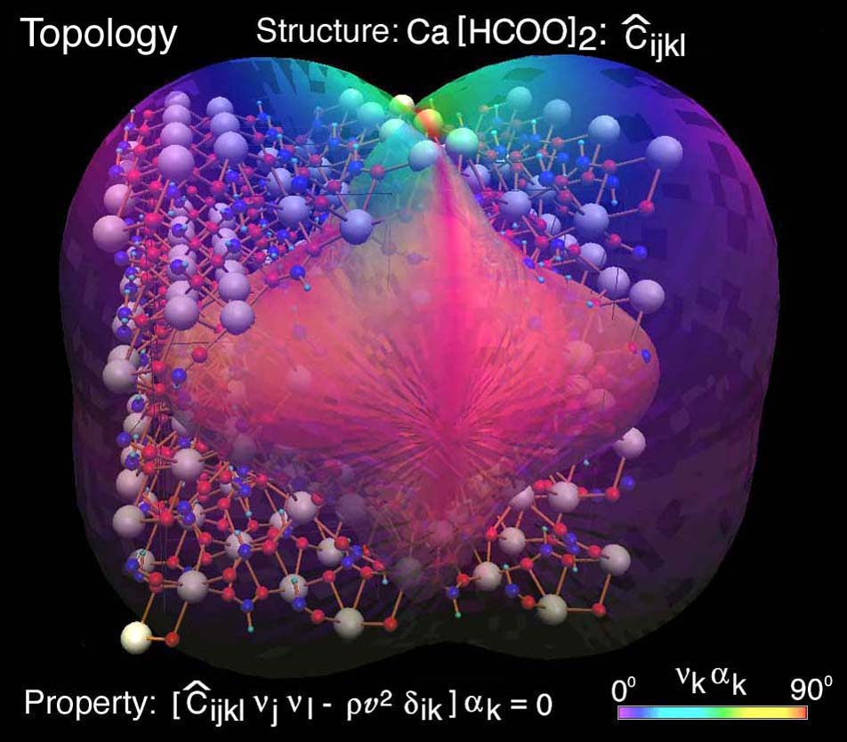
Figure 1a. Nano-Macro Topology for Ca[HCOO]2
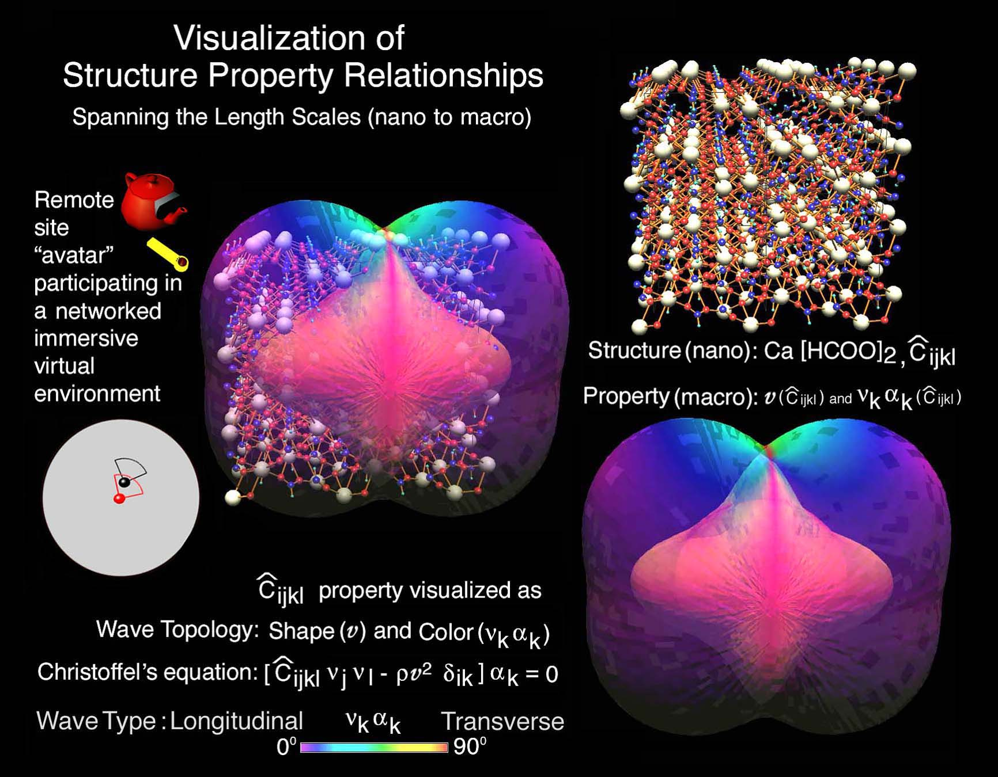
Figure 1b. Description of Nano-Macro Topology for Ca[HCOO]2

