Note: The gray shaded paragraphs are meant to be sections that are separate from the rest of the paper in separately boxed sections.

An Immersive, Interactive Scientific Visualization Environment for the Analysis of Complex Flows

Etebari, A, Pierrakos, O, Shore, M, Logie, C R, Kriz, R D, Vlachos, P P

Abstract
This paper presents a multidisciplinary approach towards the scientific visualization of experimental flow data, combining flow visualization techniques with virtual environments (VE) to represent 3D data. The acquisition, visualization, and analysis of these flows have become exceedingly difficult due to increasing volumes of data resulting from modern data acquisition systems. To overcome this obstacle, an immersive VE was developed for investigation and analysis of vortical, spatio-temporally developing flows with complex fluid-structure interactions. In-vitro flow data through mechanical heart valves inside a model of the left ventricle (LV) is used throughout this paper to illustrate the capabilities of the system. The system provides 3D visualization of the flow fields and an interactive, user-controlled environment for simultaneously comparing multiple, time-varying parameters. The VE successfully doubles the number of visualized parameters over conventional 2D systems. The system has been adapted to the DIVERSETM platform to allow networking between immersive environments and desktop systems.

Background and Significance:
The experimental investigation and analysis of complex unsteady vortical flows has always been a very tedious task. The level of complexity increases significantly in the case of spatio-temporally developing flows that involve the interaction of vortices with deformable walls and structures. These types of flows exist in the cardiovascular system, especially in the case of the flow through mechanical heart valves and inside the heart left ventricle (LV). The analysis of such systems requires a powerful scientific visualization environment.
Tools for visualizing velocities, flow field properties such as vorticity using instantaneous streamlines, unsteady streaklines, iso-surfaces, and/or volume slices of the field, have been widely used in the past. Quantitative flow visualization of the flow through the heart left ventricle (LV) and the evaluation of the hemodynamic performance of artificial heart valves is an important topic in blood flow and heart biomechanics which has received great attention in the past. Only recently advanced experimental methods such as Digital Particle Image Velocimetry (DPIV)¹ were employed for the investigation of such flows. DPIV provides global, spatially and temporally resolved experimental measurements of the flow characteristics, generating large data sets comparable to the ones from Computational Fluid Dynamics (CFD) methods. Sophisticated scientific visualization tools have not yet been employed for the analysis of such experimental data and in particular with application to biofluid mechanics. Thus, the development of such scientific visualization tools is imperative for the proper analysis and investigation of these complex flows. The purpose of this work is to integrate flow visualization experimental data from DPIV with virtual reality (VR) and create an interface for the presentation and analysis of the fluid properties.

Scientific Visualization
Computer-based scientific visualization for the representation of experimental data, as well as numerical results, is integral to our ability to understand and make inferences to the behavior of the flow, including recognition of flow structures and disturbances due to fluid-structure interactions. Scientific visualization methodologies are necessary when attempting to enhance the brain’s ability to recognize these patterns and draw such inferences, as they capitalize upon the high-bandwidth channel of the human visual system. The human brain has the ability to recognize intricate patterns embedded within complex data sets and responds mostly to changes in visual information². However, the visualization tool requires adequate rendering capabilities such that real-time, smooth data representation can be achieved.
It is well recognized that advancements in scientific visualization systems are necessary in order to efficiently represent the plethora of data acquired from experimental systems and numerical simulations³. A common solution to the task of visualizing multi-dimensional data sets such that highly correlated information can be conveyed appropriately is the use of symbols. The saying, “A picture is worth a thousand words” is true to the very essence of visual communication, as one can depict a single element of a data set, or several entities. Symbols have been used for years to communicate information, dating back to early times in the form of Egyptian hieroglyphics. Modern forms of hieroglyphics accomplish the same effect, and are known as “glyphs.” For example, the weather glyph uses a simple diagram in the form of an arrow with a circle tip to represent wind speed magnitude and direction at a particular location, as well as the sky cloud cover³. The glyph maximizes the amount of information that can be represented graphically within a limited amount of space.
The use of virtual environments in scientific visualization has been identified as advantageous in solving engineering and science problems. In recent years, increasing efforts have been directed towards the visualization of data in virtual environments (VE), which is also referred to as virtual reality (VR). Here VR and VE are used interchangeably. In particular, VR has been utilized for the display and manipulation of scientific data from natural phenomena, including weather, fluid and particle dynamics, and other information that is highly dependent upon spatial coordinate data. One VR-based data visualization project that aims to improve the usability of virtual environments is the ‘Virtual Data Visualizer’⁴, a system that acts as the basis for a toolkit for the visual analysis of complicated data sets, while giving the ability to focus the application to address specific needs.

Approach for developing an optimal visualization tool:
Methodology for improved flow visualization
The first step in the process of developing an effective visualization tool is to determine the important parameters to be represented. Beyond spatial parameters, only the most important information should be displayed, as the simulation is limited by the computational capabilities of the visualization system and the processing limitations of the user on the amount visual stimuli³. Incorporating too much information can drastically reduce the frame rate of the system, causing interruptions in playback and an overload of visual stimuli to the visual cortex, reducing the effectiveness of the simulation. In addition, an excess of visual stimuli can overload the visual cortex.
There are several flow properties other than the conventionally represented velocity and vorticity that are of particular interest in cardiovascular flow, including Reynolds stresses and wall shear stresses. This information can double, or even triple, the quantity of data that can be visualized, with each plane of data resolved into instantaneous flow information composed of tens or hundreds of thousands of points within each plane. For velocity data, six parameters are necessary to describe each flow vector, namely the three spatial coordinates and the three velocity components for each point in space. For the experimental data used herein, two thousands instantaneous frames of data were obtained, over five parallel planes across the flow field and the out-of-plane vorticity and second-order Reynolds stress tensor information are calculated and presented. For the five planes, the amount of data obtained from these experiments to describe only two seconds at a sampling rate of 1,000 Hz is on the order of hundreds of megabytes, and the memory required to visualize these parameters is on the order of ten to twenty gigabytes. We need to note that the tool is not limited to the present data but can be employed for a wide variety of flow fields. However the magnitude and content of the information presented herein is representative of the cases where this tool can be advantageous thus illustrating the need for an efficient method for visualizing such complex data sets while maintaining computational efficiency and without confusing the user.
Reynolds Stress Tensor
The characterization of turbulent flows is a difficult task, particularly in the case of experimental flow diagnostics. However, some valuable information can be determined from time-averaged data. First, consider an element with area dA in a turbulent flow field. At any given time, the velocity components at this measurement location are u, v, w. Taking the normal in the y-direction, the flow through the horizontal surfaces of the element during the infinitesimal time dt is dA v dt, and the corresponding x component of the momentum flux is thus dA uv dt. Assuming constant density, the time-averaged momentum flux is then: $d\overset{˙}{\bar{I}}=\text{dA}ρ\bar{u}\bar{v}\text{.}$ In the analysis of turbulent flow we decompose the velocity component, u, into a mean (time averaged) component $\bar{u}$, and its fluctuating component u’. This is the well known in fluid mechanics community Reynolds decomposition. The velocity components thus can be represented as $u=\bar{u}+u^{'}$ and $v=\bar{v}+v^{'}$. It should be noted that a requirement of the time averaging is that the mean velocity components must be taken over a significantly large amount of time such that the time averages of the fluctuating components are zero, corresponding to steady turbulent flow (where the mean flow is stationary), i.e. ${\bar{u}}^{'}=0$ and ${\bar{v}}^{'}=0\text{.}$
Substituting for the velocity in terms of the mean and fluctuating components, we get:
$\text{uv} = (\bar{u}+u^{'})(\bar{v}+v^{'}) = \bar{u} \bar{v}+\bar{u} v'+\bar{v} u^{'}+u^{'} v^{'}$.
Thus, $\bar{u}\bar{v} = \bar{u} \bar{v}+{\bar{u}}^{'} {\bar{v}}^{'}$, utilizing the equations given above. The flux of the y momentum in the x direction is then:
$d\overset{˙}{\bar{I}}=\text{dA}ρ\bar{u}\bar{v}=\text{dA}ρ(\bar{u} \bar{v} + {\bar{u}}^{'} {\bar{v}}^{'})$.
The flux gives the rate of change of momentum, representing a force acting against the surface dA. Dividing by the area, the stress acting on that surface is then:
$$\frac{d\overset{˙}{\bar{I}}}{\text{dA}}=ρ(\bar{u} \bar{v} + {\bar{u}}^{'} {\bar{v}}^{'})$$
The momentum flux is by definition equal and opposite to the shearing stress acting on the surface of the fluid element. Thus, the fluctuating velocity components cause additional (apparent) shear stresses known as Reynolds stresses. The component given here is thus:
$$τ_{\text{xy}}=−ρ {\bar{u}}^{'}{\bar{v}}^{'}$$
It can readily be shown that the 3D non-dimensional Reynolds stress tensor is then:
$R_{\text{ij}}=\left[\begin{matrix}u^{'_{i}^{2}} & u^{'_{i}}u^{'_{j}} & u^{'_{i}}u^{'_{w}} \\ u^{'_{i}}u^{'_{j}} & u^{'_{j}^{2}} & u^{'_{j}}u^{'_{w}} \\ u^{'_{i}}u^{'_{w}} & u^{'_{j}}u^{'_{w}} & u^{'_{w}^{2}}\end{matrix}\right]$.
A detailed and thorough derivation can be found in Schlichting (2000).

A graphical method of visualization is chosen. Ellson (1998) suggests that the dimensions and form of the glyph in the simulation should be used to represent vector terms, with the magnitude of the vector determining the dimensional length of the glyph. The time-dependency of the vector quantity can then be recognized as the change of the shape of the glyph as the simulation progresses. Scalar values are generally best represented by the color of the glyph. The success of the color map is determined upon the range of colors chosen for the display. Many simulations have used the colors of the visible spectrum to represent the scalar quantity. This is not an appropriate choice. The spectral colors do not convey the information of the values accurately, as they range from blue to red, with yellow in the middle. The failure of such a color scheme lies in the fact that a ‘hot’ color, or one to which the eye is particularly attracted, i.e. yellow, should represent an extreme value, not a middle value. In analyzing a complex flow, we are mainly interested in how rapidly each flow parameter is changing and the magnitude of its extreme values. For the case of turbulent flow, the behavior of the flow is characterized by random fluctuations and high velocity gradients. The investigation of turbulence has significant implications in a variety of fluid dynamics problems, including boundary layer phenomena, wave and wake propagation, and drag reduction. Accordingly, the extreme values of a scalar parameter are mapped to these so-called ‘hot’ colors for the visualization system presented herein.
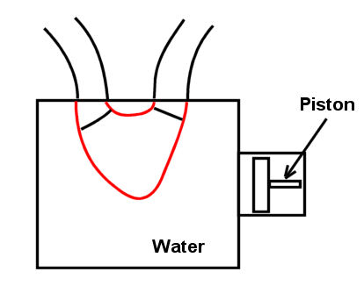
Figure 1: Heart Simulator Setup
Application to Cardiovascular Flow:
Time-Resolved Digital Particle Image Velocimetry (TRDPIV) is a non-intrusive state of the art global flow measurement technique that has been developed over the past five years. A major advantage of TRDPIV over preexisting methods is the ability to provide global spatio-temporal description of 3D flow patterns with high spatial and frequency resolution, such that the turbulent characteristics of the flow are measurable. However, the data analysis process is limited by current visualization methods that are generally capable of only 2D representations.
We have acquired extensive TRDPIV data from in-vitro experiments in various flow fields, including flow over bluff bodies, two-phase flows, and cardiovascular flows. Of particular interest is the behavior of fluid flow through the left ventricle. A heart simulator machine was developed for the testing of mechanical and biological heart valves. The heart machine (Figure 1) uses a piston-driven chamber to generate physiological contractions of a synthetic ventricle.
Data Acquisition System:
TRDPIV provides instantaneous plane velocity measurements of the flow field. Detailed description of the principles of the method can be found in Willert and Gharib (1991), Westerweel (1993). The system used is based on a 55-Watt pulsing laser that illuminates the area of interest. The flow is seeded with neutrally buoyant fluorescent particles, which serve as flow tracers. A CMOS video camera is synchronized with the laser to capture with up to 1000 frames/sec and 512x512 pixel resolution the instantaneous positions of the particles. The task of the velocity evaluation is carried out using a conventional cross-correlation between the particle image patterns of two consecutive frames. A detailed description of the system is found in Vlachos (2000). For the present work data are acquired along a sequence of parallel planes to allow the reconstruction a volume of the flow field. A schematic of our setup is shown in Figure 2.
Figure 2: DPIV Setup

3d interactive, immersive, VE for visualization of complex flows
For the visualization of flow data within the left ventricle, the most important parameters include the spatial (x-, y-, and z-dimension) coordinates, the velocity components (u, v, and w corresponding to the x-, y-, and z-dimensions), and vorticity perpendicular to the plane of interrogation. In addition to these parameters, we would like to be able to visualize the calculated second-order Reynolds stress (described below), tensor in order to identify the regions of high-level turbulent energy transfer. To represent the parameters in a compact yet comprehendible manner, our system utilizes glyphs to represent the data. The glyph designed for the heart flow simulation consists of a cone attached to an ellipse, as shown in Figure 3. The cone represents the magnitude of the velocity at a single point, and its orientation the direction. The ellipse is scaled to the values of the symmetric Reynolds stress tensor (described below) at that point, with the lengths along the axes perpendicular to the axis of the cone representing the two in-plane Reynolds stresses, and the axial length corresponding to the cross-correlation term between the two. The color of the glyph represents the magnitude of the vorticity, with brighter colors indicating severe or extreme values. Thus, one single glyph concisely represents nine flow parameters for a single point within the flow.
For the present time, and for the purposes of the following examples, the 3-D glyphs are confined to a 2-D plane because the acquired experimental TRDPIV data were limited to measurements within that plane at that time. The visualization system is however capable of representing 3-D data, such that when actual volumetric data is acquired the VE is designed to accommodate the data. Moreover, our measurement system is currently capable of 3d velocity measurements.
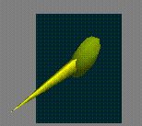
Figure 3: Flow vector glyph

Virginia Tech CAVETM and DIVERSETM
The Virginia Tech CAVETM (Cave Automated Virtual Environment) was used to develop the scientific visualization system. The CAVETM is a 10’ x 10’ x 9’ theater, consisting of projection screens on the front and side walls. Stereo goggles bring two slightly offset images into focus in front of the walls, giving the user the illusion of immersion within the visualization. The viewpoint of the user is controlled by a six-degree-of-freedom electromagnetic sensor in the goggles, and manually using a similar sensor in a joystick controlled by the user. A major advantage of the CAVETM system is that it is a fully networkable collaborative environment, and is cross-platformed for use on any computer system through the DIVERSE platform [www.diverse.vt.edu]. Thus, a scientist running the simulation in the Virginia Tech CAVETM could communicate with a cardiologist halfway across the world viewing the same simulation on a desktop PC, allowing fast and easy communication of data for analysis where conventional systems would be limited to a localized group of users. Avatars, which are essentially simple human models, virtually represent the users with in the simulation, and headsets are used for verbal communication between the users [Collaborative Tools: www.sv.vt.edu/future/cave/software/D_collabtools/D_collabtools.html].
DIVERSE was developed as a free and open source solution to immersive VR. The developers placed great emphasis on making the system portable (so it would run on many different computers). They also wanted the system to be hardware agnostic, so that many different tracking, input, and display devices could be used without having to rewrite or recompile user code. Originally, DIVERSE only worked with Performer, a graphics library from SGI. However, later additions allowed development using the more standard OpenGL.
The structure of DIVERSE for OpenGL (DGL) is similar to the CAVElib library, which the original heart flow program used. This made it a relatively easy task to port applications to DGL. Moving to DGL allowed us to take advantage of the cross-hardware support that DIVERSE excels at. Different navigation models, written independent of the heart flow program, can be used without any code changes. Also, the program can be used both in a CAVE, on the desktop, or any other system that DIVERSE supports, with no code changes. Most importantly, because DIVERSE is free and open-source, it allows for easy adoption.

Results:
Visualization of In-Vitro Left Ventricular Flow Data
To illustrate the effectiveness of the scientific simulation toolkit developed herein, we present a data set for the heart LV, made up of five separate planes with grids of 125 x 125 points, which are displayed as glyphs. The areas that appear to be denser than others, those near the top, are regions of high Reynolds stress. The vorticity is represented by the color of the glyphs, with brighter colors signifying higher values of vorticity. Figure 4 shows a pair of images displaying the full time-averaged (averaged over the entire heart cycle) flow through the heart, from both the frontal view and an oblique view. The system has the advantage that it almost doubles the number of visualized parameters from six (x, y, x-velocity, y-velocity, time, and vorticity) to eleven (x, y, z, x-velocity, y-velocity, z-velocity, time, vorticity, and three Reynolds stress parameters) in going from a 2D representation to immersive 3D. In addition, five planes are visualized simultaneously, as opposed to just a single plane of data. For the present study there are no out-of-plane velocity or Reynolds stress data available; hence glyphs shown in Figures 5-7 have no out-of-plane components. However, the visualization system is designed such that it is capable of displaying true three-dimensional volumetric data, of which our TRDPIV system is currently capable of obtaining.
The scientific visualization software is designed as a tool for interactive simulation and analysis. As such, the single most important aspect of the software is its user-controlled design. The scientist can move through the tens of thousands of data points, and probe or isolate points/areas of particular interest or concern using a cone-shaped virtual probe wand. Once a point is highlighted, it is enlarged such that it stands out from the rest of the points, and is shown above on a pop-up display. Once the user has selected a point in the data set, there are various options for controlling the simulation. For example, with the push of a button the simulation can be altered such that a new set of glyphs are used to isolate only selected parameters, such as a set of contour surfaces representing only the spatial distribution of the Reynolds stress tensor (Figure ). Each contour is made up of cylinders of equal height, with the two horizontal axes scaled to the in-plane values of the tensor, and the color according to a cross-correlation term. By clicking a second button, a set of points can be highlighted to identify a group of points that have a vorticity or Reynolds stress level close to the value of the selected point.
In addition, time resolved three-dimensional velocity, vorticity, and Reynolds stress data are imported into the virtual environment. Each time step allows for instantaneous changes in the velocity magnitude and direction associated with each coordinate, creating a time-dependent series of frames that depicts the state of the velocity field as it changes in time, or frame-by-frame as controlled by the user in the CAVETM environment. The user can then move through the flow and view the flow field from the perspective of a particle in the field. Although the planes of data are not acquired simultaneously, they are triggered at the same point in the heart cycle, and the experiments have been repeatable.

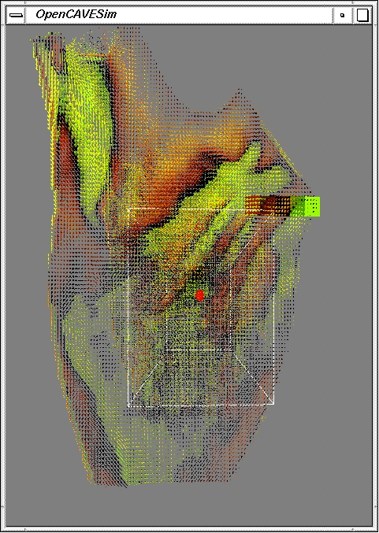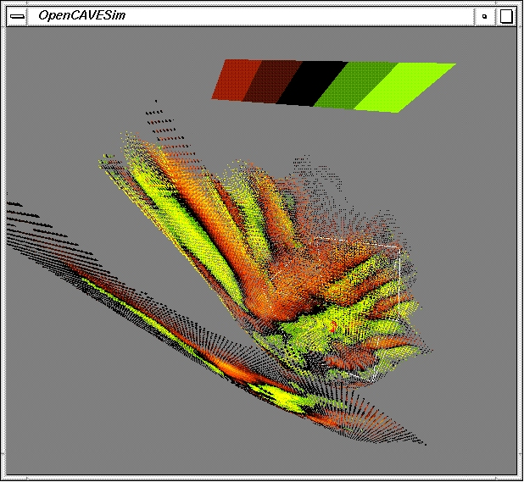
Figure 4: 3-D time-averaged flow through left ventricle (5 planes); (a) front view (b) oblique view

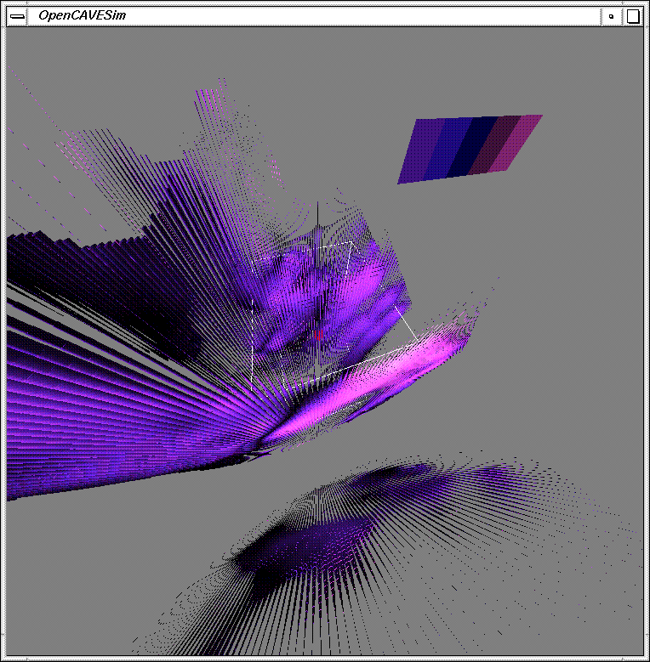
Figure 7: Full 3-D Reynolds stress glyphs

The series of pictures shown below in Figure 8 represent six time-steps of an unsteady heart flow data set. The user is viewing the simulation from the top of the heart on the aortic side. The arrows point up and out of the picture at the top left represent the outflow of blood through the aorta. The arrows point in the direction of the flow at each point in space and time, and the color is scaled to the value of the vorticity, according to the legend shown in the upper right-hand corner. The vortices can be easily followed as they move through the heart for multiple layers of data. The visualization gives valuable insight into the spatial development of the inlet and outlet flow through the ventricle. In the middle planes, three coherent jets can be seen entering separated by the rigid leaflets of the valve. In the outer planes these jets are less distinct, and almost converge into a single jet due to the complex interaction between the fluid and the compliant wall. The presence of multiple jets entering the ventricle give rise to turbulent flow structures within the ventricle which propagate through the aortic valve, exiting the ventricle. The Reynolds stress visualization supports this observation, with the highest shear levels located in the three incoming jets, indicating that most damage done to the blood constituents occurs in this inlet region, with the flow disturbance penetrating into the center of the ventricle.

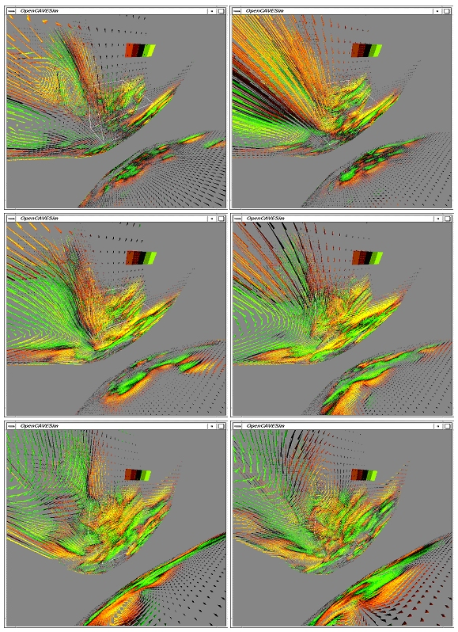
Figure 8: Unsteady time-series of 3-D flow glyphs in the left ventricle (left-to-right then down)
Conclusions

A virtual environment for the experimental investigation and analysis of complex vortical flows was created, with an interface between experimental TRDPIV data obtained in our laboratory using our heart simulator and a state-of-the-art 3-D virtual reality system. 3-D glyphs are used to represent locally the flow in the virtual environment in a concise and informative manner. This new system has a major advantage over conventional 2-D systems in that it successfully increases the number of visualized parameters from six (x, y, x-velocity, y-velocity, time, and vorticity) to eleven (x, y, z, x-velocity, y-velocity, z-velocity, time, vorticity, and three Reynolds stress parameters), and five planes (or more depending upon the available data) are visualized simultaneously, rather than just a single plane of data.
The simulation allows for instantaneous changes in the velocity magnitude and direction associated with each coordinate, creating a time-dependent series of frames that shows the dynamical nature of the flow in the CAVETM environment. The user controls his/her viewpoint, and can thus navigate through the simulation and view the flow field from any perspective in the virtual environment. The simulations give full 3-D visualization of the experimental flow, resulting in an increased capability of analyzing and interpreting complex three-dimensional flow fields over conventional systems.
- Willert C E and M Gharib, Digital Particle Image Velocimetry. Experiments in Fluids 10, 181-193, 1991.
- Kosslyn, S. M., Chabris, C., “The Mind is Not a Camera, The Brain is Not a VCR,” Aldus Magazine, September/October, 1993.
- Ellson, R., Cox, D., “Visualization of Injection Molding,” Simulation, November, 1988.
- van Teylingen, R., Ribarsky, W., van der Mast, C. “Virtual Data Visualizer,” IEEE Transactions on Visualization and Computer Graphics, Vol. 3, No. 1, January-March, 1997.
- Westerweel J., Digital Particle Image Velocimetry, Theory and Application. Delft University Press, 1993.
- Vlachos, P. P., An Experimental Spatio-Temporal Analysis of Separated Flows over Bluff Bodies Using Quantitative Flow Visualization. PhD Dissertation, Virginia Tech, 2000.
- Schlichting, H and Gersten, K, “Boundary Layer Theory,” New York: Springer-Verlag, 2000.
- Brill, M., Hagen, H., Rodrian, H-C., “Streamball Techniques for Flow Visualization,” IEEE, 1994
- Crawfis, R. A., Livermore, L. “Texture Splats for 3D Scalar and Vector Field Visualization,” IEEE, 1994.
- Curry, K. M., “Supporting Collaborative Awareness in Tele-immersion,” Masters Thesis, Virginia Tech, 1999.
- Delmarcelle, T., and Hesselink, L., “Visualizing Second-Order Tensor Fields with Hyperstreamlines,” IEEE Computer Graphics & Applications, July,1993.
- Forssell, L. K., “Visualizing Flow Over Curvilinear Grid Surfaces Using Line Integral Convolution,” IEEE Computer Graphics & Applications, 1994
- Garcke, H., Preuber, T., Rumpf, M., Telea, A. C., Weikard, U., van Wijk, J. J., “A Phase Field Model for Continuous Clustering on Vector Fields,” IEEE Transactions on Visualization and Computer Graphics, Vol. 7, No.3, July-September, 2001.
- Hellmann, J. L. and Hesselink, L., “Visualizing vector field topology in fluid flows,” IEEE Transactions on Computer Graphics Applications, Vol. 11, No. 3, 1991.
- Hesselink, L., Post, F. H., van Wijk, J. J., “Research Issues in Vector and Tensor Field Visualization,” IEEE Computer Graphics and Applications, Visualization Report, March, 1994.
- Itoh, T., Yamaguchi, Y., Koyamada, K., “Fast Isosurface Generation Using the Volume Thinning Algorithm,” IEEE Transactions on Visualization and Computer Graphics, Vol. 7, No. 1, January-March, 2001.
- Jones, S. T., Parker, S. E., Kim, C. C., “Low-Cost High-Performance Scientific Visualization,” IEEE Computing in Science & Engineering, July/August 2001.
- Kaltenborn, K.F., and Rienhoff, O., “Virtual Reality in Medicine,” Methods of Information in Medicine, Vol. 32, No. 5, pp. 407-417, 1993.
- Leigh, J., Bailey, S. “A Tele-Immersive Environment for Collaborative Exploratory Analysis of Massive Data Sets,” ASCI 1999, June, 1999.
- Oohigashi, M., Cingoski, V., Kaneda, K., Yamashita, H., “A New Method for 3-D Vector Field Visualization Utilizing Streamlines and Volume Rendering Techniques,” IEEE Transactions on Magnetics, Vol. 34, No. 5, September, 1998.
- Ueng, S-K., Sikorski, C., Ma, K-L., “Efficient Streamline, Streamribbon, and Streamtube Constructions on Unstructured Grids,” IEEE Transactions on Visualization and Computer Graphics, Vol. 2, No. 2, June, 1996.
- van Wijk, J. J. “Flow Visualization with Surface Particles,” IEEE Computer Graphics & Applications, July, 1993.
- Westerweel, J., “The Effect of a Discrete Window Offset on the Accuracy of Cross-correlation Analysis of Digital PIV Recordings.” Exp. In Fluids, Springe r Verlag, Vol. 23, pp. 20-28, 1997.
- Westermann, R., Johnson, W., Ertl, T., “Topology-Preserving Smoothing of Vector Fields,” IEEE Transactions on Visualization and Computer Graphics, Vol. 7, No. 3, July-September, 2001.
- Wittnenbrink, C. M., Pang, A. T., Lodha, S. K., “Glyphs for Visualizing Uncertainty in Vector Fields,” IEEE Transactions on Visualization and Computer Graphics, Vol. 2, No. 3, September, 1996.
- Wischgoll, T., Scheuermann, G., “Detection and Visualization of Closed Streamlines in Planar Flows,” IEEE Transactions on Visualization and Computer Graphics, Vol.7, No. 2, April-June, 2001.

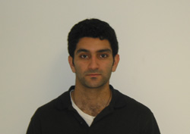
Ali Etebari is a PhD candidate in Biomedical Engineering at Virginia Tech. He received his BS and MS in Engineering Mechanics at Virginia Tech, with a biomechanical option. His research interests include scientific visualization of complex data sets, image processing for clinical applications, wall shear stress measurement and estimation, and non-invasive flow diagnostics.

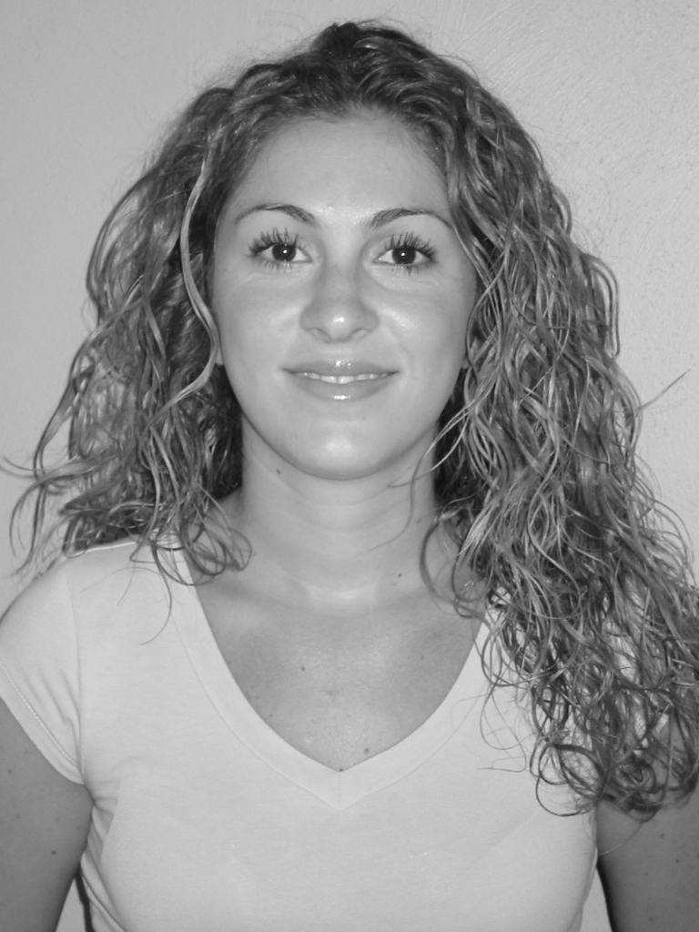
Olga Pierrakos is a PhD candidate in Biomedical Engineering at Virginia Tech. She received her BS and MS in Engineering Mechanics at Virginia Tech. Pierrakos’ research interests include cardiovascular hemodynamics, left ventricular flow dynamics, flow past prosthetic heart valves, and cardiac remodeling. She has received numerous scholarships and fellowships, including the VT Advance Fellowship.

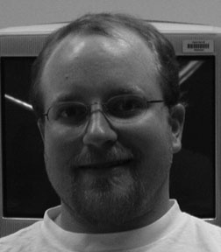
Michael Shore is an undergraduate student in Computer Science at Virginia Tech. His work and studies have focused around graphics and virtual environments. He is the author of DVTK, an interface that allows Visualization Toolkit developers to run their applications in an immersive environment using the DIVERSE API.
Contact address: McBride Hall, Computer Science (0106), Virginia Tech, Blacksburg, Virginia 24061


Christopher R. Logie is a MS candidate in computer science at New York
University. He received the BS degree in computer science from Virginia
Tech in 2001. His research interests lie in the area of computer graphics,
and include geometric modelling, non-photorealistic rendering, and three
dimensional user interfaces.

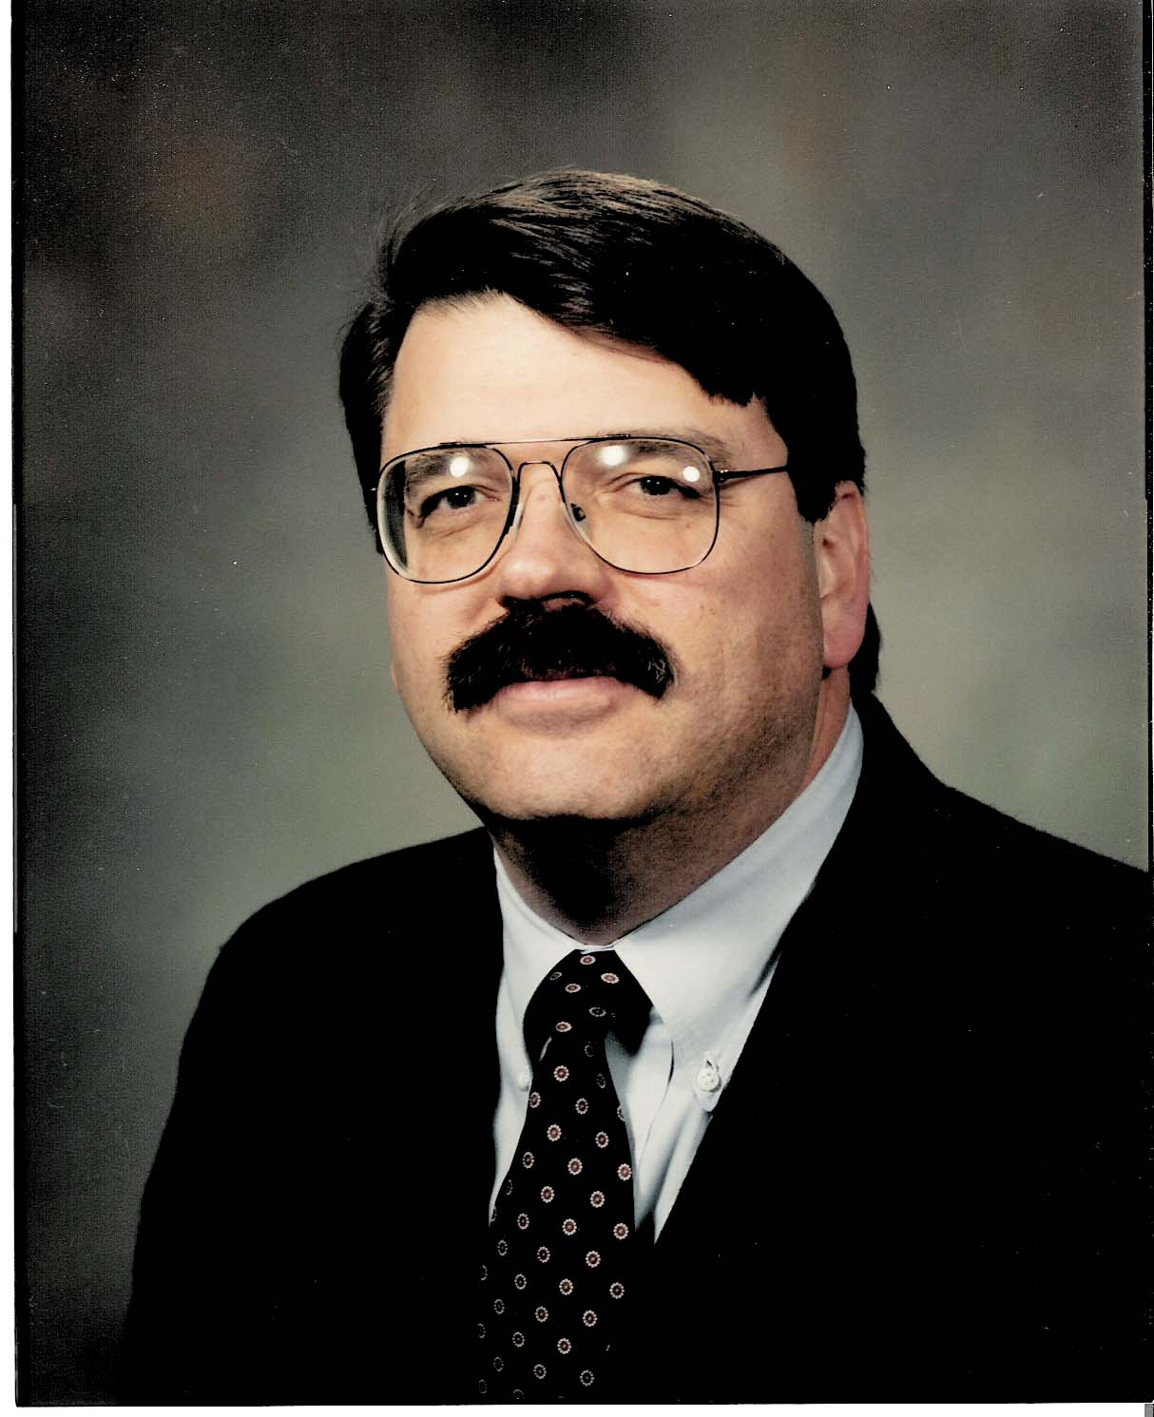
Ronald D. Kriz is an Associate Professor in the College of Engineering at Virginia Tech. His research interests include supercomputing, scientific visualization, virtual environments, and wave propagation. Kriz received his MS and PhD in Engineering Mechanics from Virginia Tech, and BS from California Polytechnic State University. He conducted Materials Research Engineering research at NIST for ten years. Kriz returned to Virginia Tech, where he founded the Laboratory for Scientific Visual Analysis in 1991 as an academic affiliate with NCSA. In 1996 he was awarded NSF funds to build a CAVE(tm) facility in collaboration with NCSA which is now affiliated with Virginia Tech's Institute for Critical Technologies in the Applied Sciences (ICTAS), 2004. Contact address: Norris Hall, ESM (0219), Virginia Tech, Blacksburg, Virginia 24061


Pavlos P. Vlachos is Assistant Professor in Mechanical Engineering at Virginia Tech. He received his BS in Mechanical Engineering from National Technical University of Athens, and MS and PhD from Virginia Tech. His research focuses on experimental fluid mechanics specialized in optical flow diagnostics addressing a variety of fluid mechanics problems, primarily, cardiovascular fluid mechanics, multi-phase flows, and active flow control. Dr. Vlachos has authored approximately 40 technical papers.

